Test Plan
Test 1: Basic/existing functionality after restructure of hierarchy
Input: ((a + 4) - (b + 5)), a = 3, b = 6;
Expected output: -4
Output:
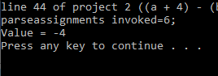
Pass.

Test 2: New binary operators
Input:
((x * 2.6) + (y - 3)), x = 1.5, y = 6;
((8 / z) + (z ^ 2)), z = 2;
((6 % b) < 5), b = 4;
(c > d), c = 9, d = 7;
(e & 8), e = 5;
Expected output:
6.9
8
2
9
6.5
Output:
Got an error. Upon walking through carefully, I realized the code doesn’t know how to consume a decimal number yet, so I’m modifying the test and will go back to that later.
Input:
((x * 2) + (y - 3)), x = 1, y = 6;
((8 / z) + (z ^ 2)), z = 2;
((6 % b) < 5), b = 4;
(c > d), c = 9, d = 7;
(e & 8), e = 5;
Expected output:
5
8
2
9
6.5
Output:
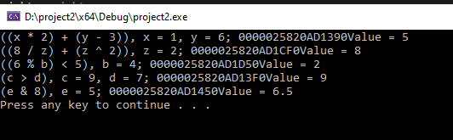
Pass.

Test 3: Unary and ternary operations
((a + 4) ~), a = 3;
(f ? 1 2), f = 0;
Expected output:
-7
2
Output:
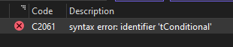
I had failed to uncomment an #include, so I fixed that.
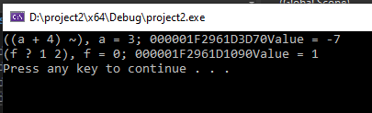
Appears to be a logic error. Stepping through it, I missed the call to consume the rightmost parenthesis. (I also got rid of the extra print statement I had stuck in there.)
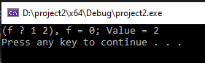
Pass.

Test 4: Quaternary operation
Input: (g # 1 2 3), g = 2;
Expected output: 3
Output:
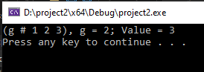
Pass.

Test 5: Underscores
Input: (g_h # 1 2 3), g_h = 2;
Expected output: 3
Output:
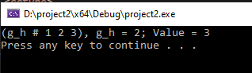
Pass.

Test 6: Floating point literals
Input: ((x * 2.6) + (y - 3)), x = 1.5, y = 6;
Expected output: 6.9
Output:
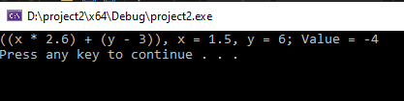
I was accidentally consuming the value twice.
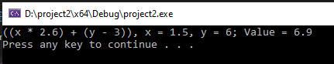
Pass.

Test 7: double-initialized variable
Input: (aa + 1), aa = 1, aa = 2;
Expected output: "Variable name already used"
Output:
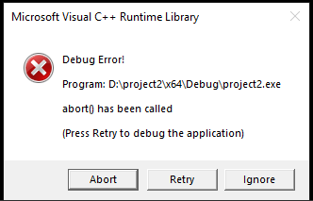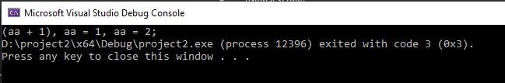
Updated the catch block to print e.what().
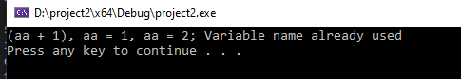
Pass.

Test 8: uninitialized variable
Input: (tt + ss), tt = 2;
Expected output: ERROR: Variable was not initialized
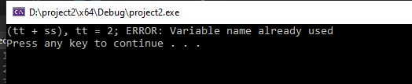
Logic error: defined that exception as == instead of !=.
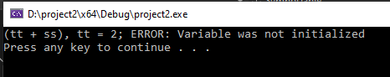
Pass. I also reran test 7, which still passed.

System test:
System test will only run one exception, so the last line will not complete. As I just tested that last line, I think that’s fine.
Input:
((a + 4) - (b + 5)), a = 3, b = 6;
((a + 4) ~), a = 3;
((x * 2.6) + (y - 3)), x = 1.5, y = 6;
(( 7 / z_1) + (z_1 ^ 2)), z_1 = 2;
((6 % b) < 5), b = 4;
(c > d), c = 9, d = 7;
(e & 8), e = 5;
(f ? 1 2), f = 0;
(g # 1 2 3), g = 2;
(tt + ss), tt = 2;
(aa + 1), aa = 1, aa = 2;
Expected output:
-4
-7
6.9
7.5
2
9
6.5
2
3
ERROR: Variable was not initialized

Output:
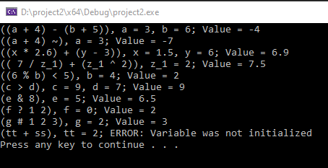
Pass.

